ROTHER VALLEY RAILWAY SUPPORTERS ASSOCIATION

BULLETIN

Good news and bad news…….

The good news is that last year we invited a representative from Her Majestys Railway Inspectorate to come to the Railway for an informal visit. In advance of the formal inspection that will be necessary before we can commence a public fare paying passenger carrying service, this was to avoid last minute nasty surprises by ensuring, as much as possible, that work was being carried out satisfactorily, fully and to required standards.

We are pleased to report that we generally got the “thumbs up” but a couple of major obstacles appeared, one of which is the subject of this Bulletin and appeal for funds. It was clear that the 3 way point at the station throat would not be acceptable to HMRI and it has been necessary therefore to plan and prepare for quite major track alterations. The plans are as follows;

New above, Existing below;

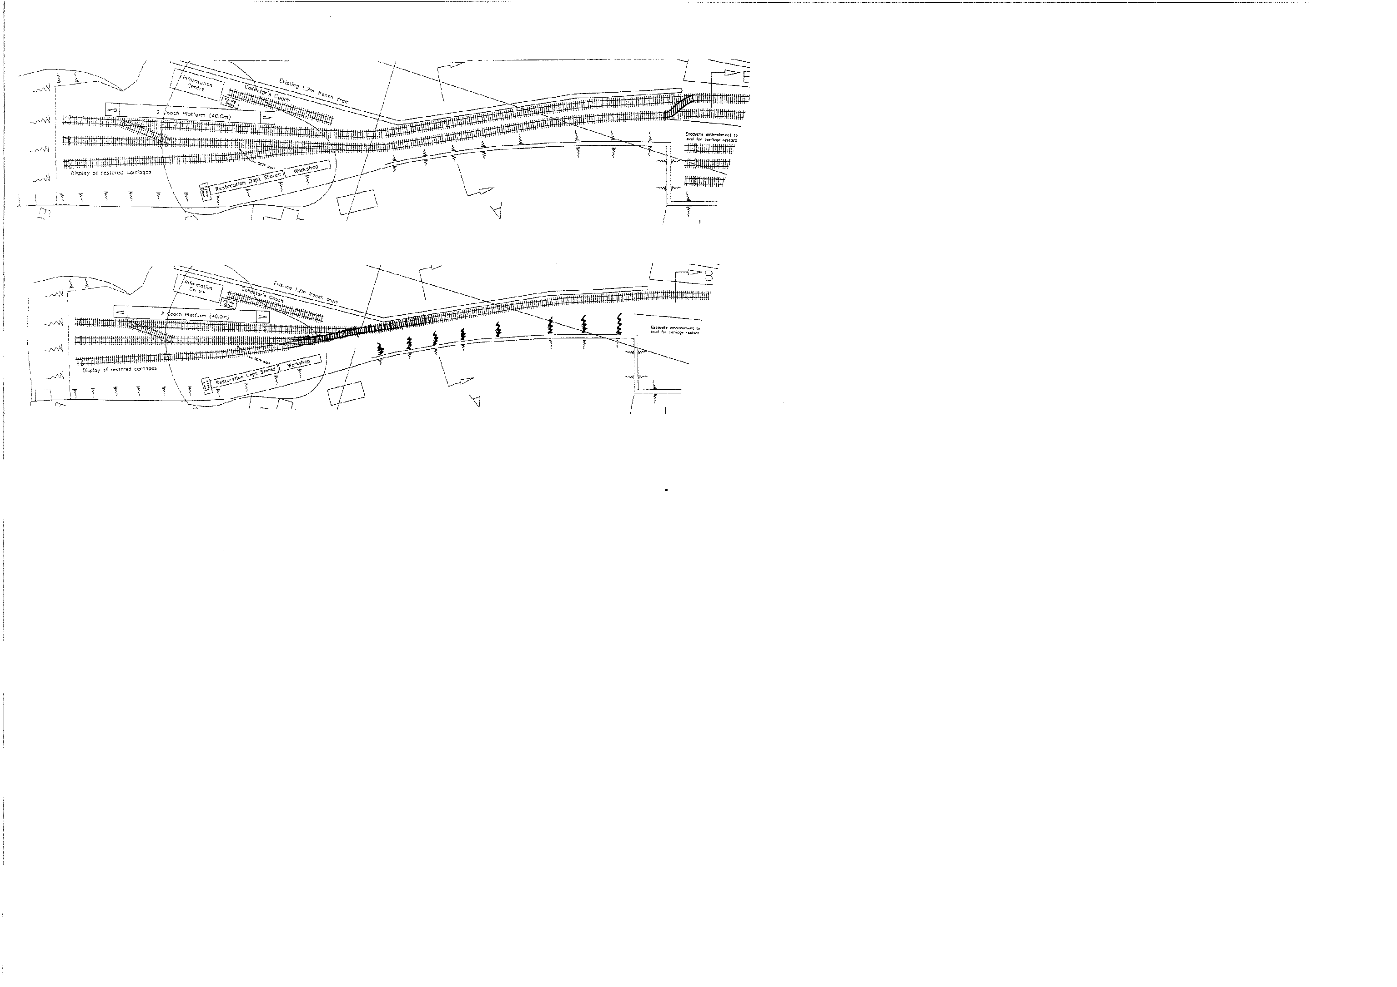

Association volunteers have been hard at work in recent months and the area for the run round loop has already been dug out, cleaned and levelled and drains installed and it is now ready for tracklaying. In addition, we either already have or, thanks to a very generous donation from a close supporter, have sufficient funds to purchase all the rail, ballast and other materials we require for the job, except for the sleepers.

The committee have decided to use concrete chaired sleepers on this section, which, although heavier and more difficult to handle, have advantages in not requiring many hundreds of holes to be drilled to affix the chairs, they will eliminate maintenance and they will also complement the appearance of the existing parallel running line.

[CONTINUED OVER
- 2 -

In 2002; Currently;

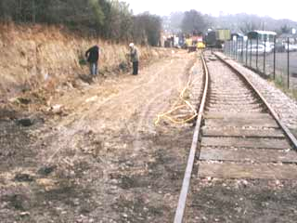
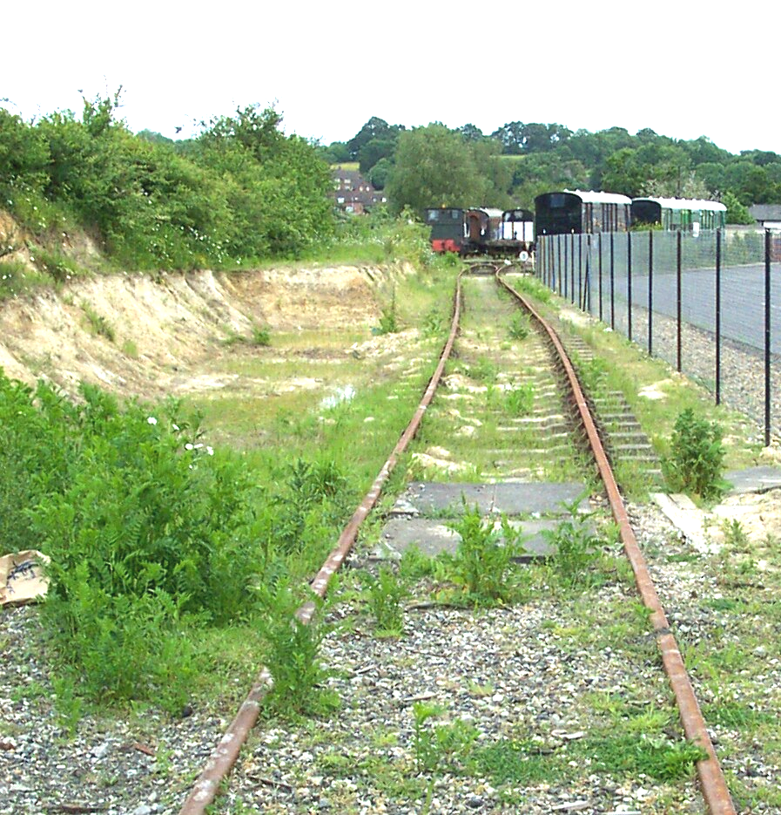

Now the really bad news…..

We really do need your help and we are launching a “SPONSOR A SLEEPER” scheme. Hardly original we know, but needs must… We require 100 sleepers which co-incidentally is one for each current member. Including transport these sleepers cost £20 each and we are asking all members if they would donate such an amount and buy “their” sleeper. You may of course buy more than one if you wish. A sleeper wall with sponsor names will be kept on display at the station. If you wish to have a particular numbered sleeper, we will try to accommodate your wish, but it will be on a “first come” basis.

We need more (and better) ones of these;
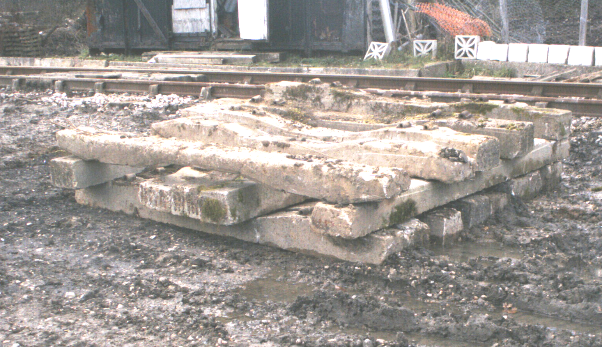

Please complete and return the attached slip with your cheque, made payable to “Rother Valley Railway Supporters Association” to the Treasurer, RVRSA, Robertsbridge (RVR) Station, Station Road, Robertsbridge, East Sussex TN32 5DG as quickly as possible.

REMEMBER, THE QUICKER WE COMPLETE THE WORK, THE QUICKER WE WILL BE ABLE TO RUN TRAINS.

RVRSA “SPONSOR A SLEEPER” APPEAL

To: The Treasurer, RVRSA, Robertsbridge (RVR) Station, Station Road, Robertsbridge, East Sussex. TN32 5DG

1, ……………………………………………………….….. Member no ………………………

wish to sponsor ….…..(number) sleeper(s) (number(s) ……..…..(if applicable; between 1 and 100 only)

I enclose my cheque, to Rother Valley Railway Supporters Association, for £ …………..…….

